**6.IR control Clip**

**1.Preparation**

1.You should learn about the position of the infrared receiver in the body of hellobot；

2.You should learn about the principle of the infrared infrared receiver.

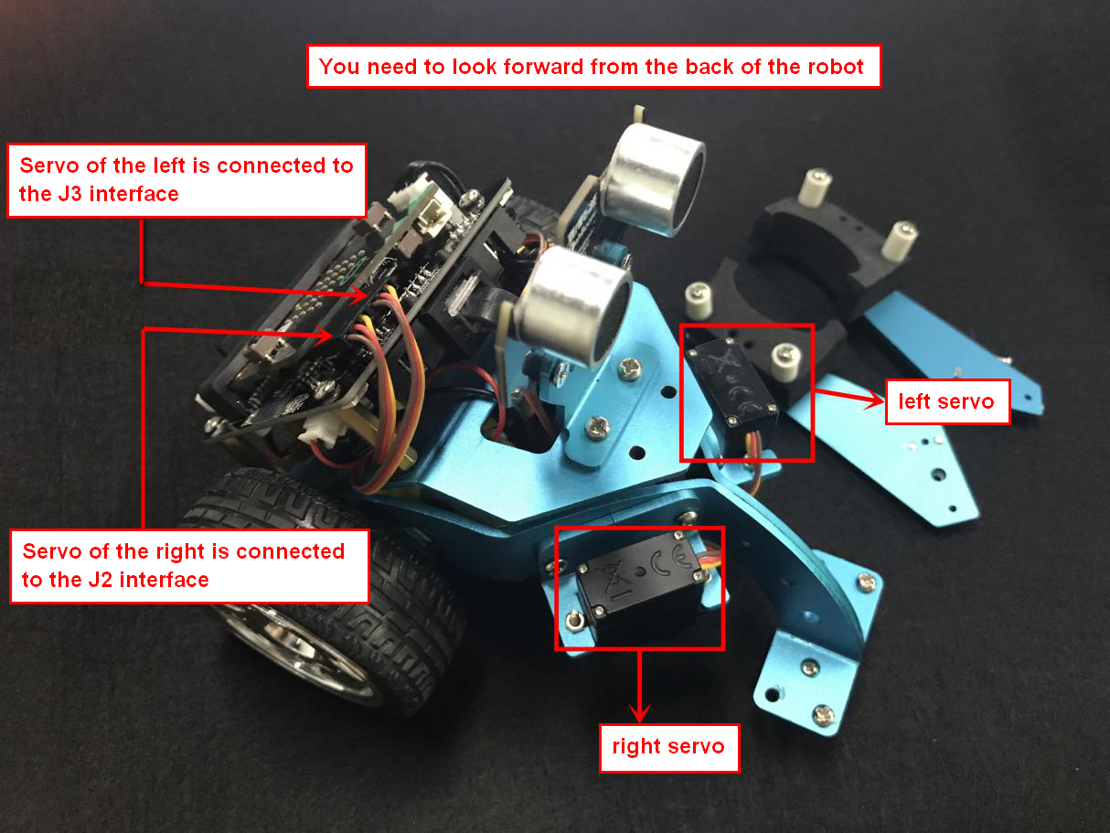

6-1 wiring of servo

You need to connect the wiring of the servo to the expansion board, and the servo of the left is connected to the J3 interface and the servo of the right is connected to the J2 interface. The brown line of the servo corresponds to GND, the red line corresponds to VCC, and the yellow line corresponds to IO.

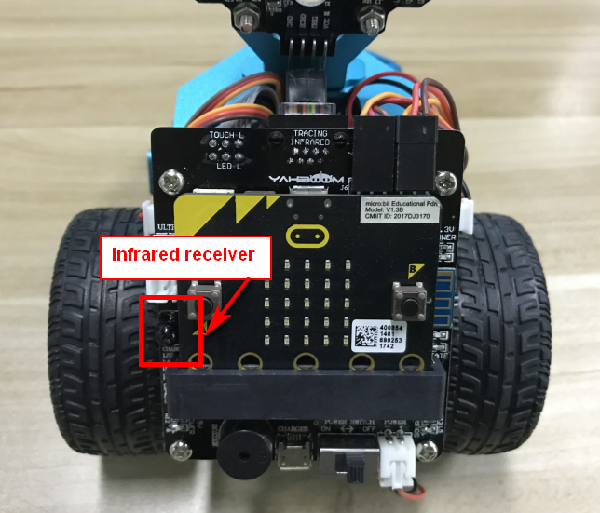

6-2 position of the infrared receiver in the body of hellobot

The infrared receiver is integrated on the left side of the expansion board. When you use the infrared remote controller, the remote controller needs to be aligned with the infrared receiver to receive the signal and perform corresponding actions.

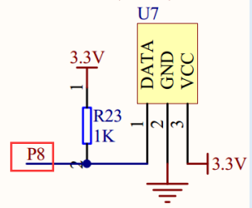

6-3 schematic

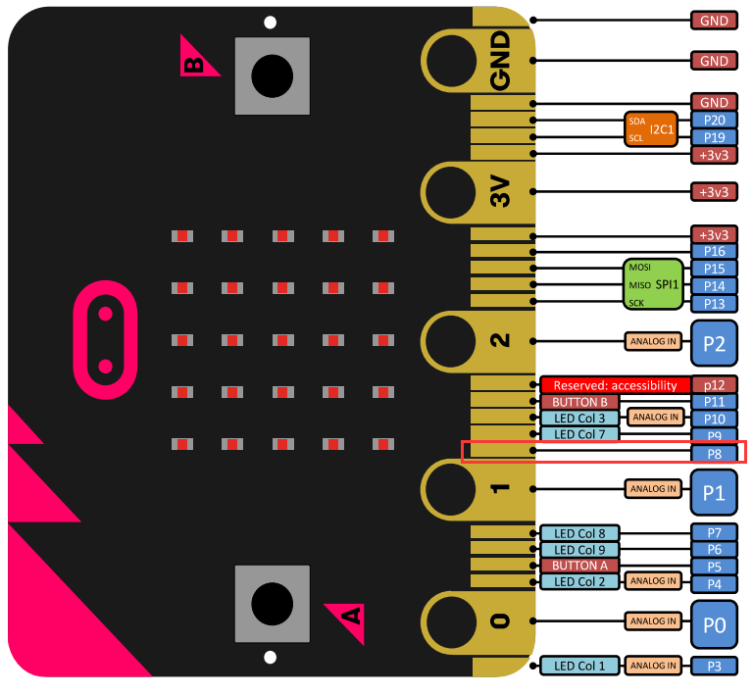

6-4 Pins of Micro:bit

From the schematic diagram. You can see that infrared receiver is connected to P8 of Micro:bit. Therefore, in the program, it is necessary to initialize the infrared receiving pin, and then you can write the program to set the action corresponding to the key value of the infrared remote control.

**Infrared remote control principle:**

**The infrared remote control emits modulated infrared light waves; the infrared receiver receives the infrared signals and converts them into corresponding electrical signals, which are then sent to the post amplifier. In this experiment, we used an infrared remote controller to control the movement of the car.**

**! Note:**

**The tracking colorful lights of the car use P5 pin of micor:bit board. It is multiplexed with the pins of the micro:bit LED dot matrix. Before using this function, we can turn off the micro:bit LED dot matrix display.**

**Note:**The infrared obstacle avoidance sensor is not working properly due to the interference of outdoor light. This course needs to be carried out indoors and the curtains are covered to block the outdoor light.

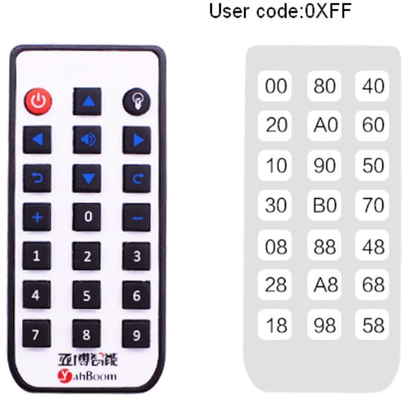

6-5 Infrared remote control code value

// 00FF00FF  change the color of the line lights

// 00FF30CF  clamp close

// 00FF708F  clamp open

// 00FF40BF  change the color of the line lights

// 00FFA05F  stop

// 00FF807F  advance

// 00FF20DF  turn left

// 00FF609F  turn right

// 00FF906F  back

// 00FF10EF  turn left in place

// 00FF50AF  turn right in place

// 00FFB04F 0 buzzer sound

// 00FF08F7 1 change the color of the line lights

// 00FF8877 2 change the color of the line lights

// 00FF48B7 3 change the color of the line lights

// 00FF28D7 4 change the color of the body lights

// 00FFA857 5 change the color of the line lights

// 00FF6897 6 change the color of the body lights

// 00FF18E7 7 change the color of the body lights

// 00FF9867 8 change the color of the line lights

// 00FF58A7 9 change the color of the body lights

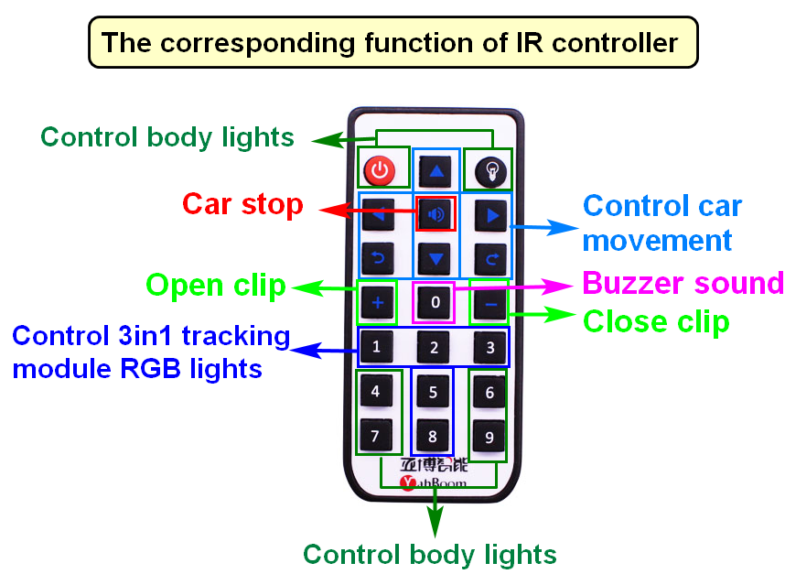

1. **Learning goals**

In this course, we will study how to control car by infrared controller.

**3.Programming**

3.1 Programming online

**1) You should use the USB cable to connect the micro:bit to the computer, at this point, the computer will have a micro:bit U disk. You need to open it, click micro:bit website, then entered the micro:bit website** or you can enter the URL directly in your browser: http://microbit.org/

2) After entering the programming interface, you need to click Add package and copy the HelloBot package URL: https://github.com/lzty634158/HelloBot to the input field, click to confirm the add package. Then you can use the blocks of the HelloBot package.

3.2 Programming offline

1) You can double-click to use it. As shown in the following figure.

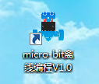

2) After entering the programming interface, you need to click Add package and copy the HelloBot package URL: https://github.com/lzty634158/HelloBot to the input field, click to confirm the add package. Then you can use the blocks of the HelloBot package.

Note: The package only needs to be added once. If you have added packages in the previous lessons, this course does not need to be added repeatedly.

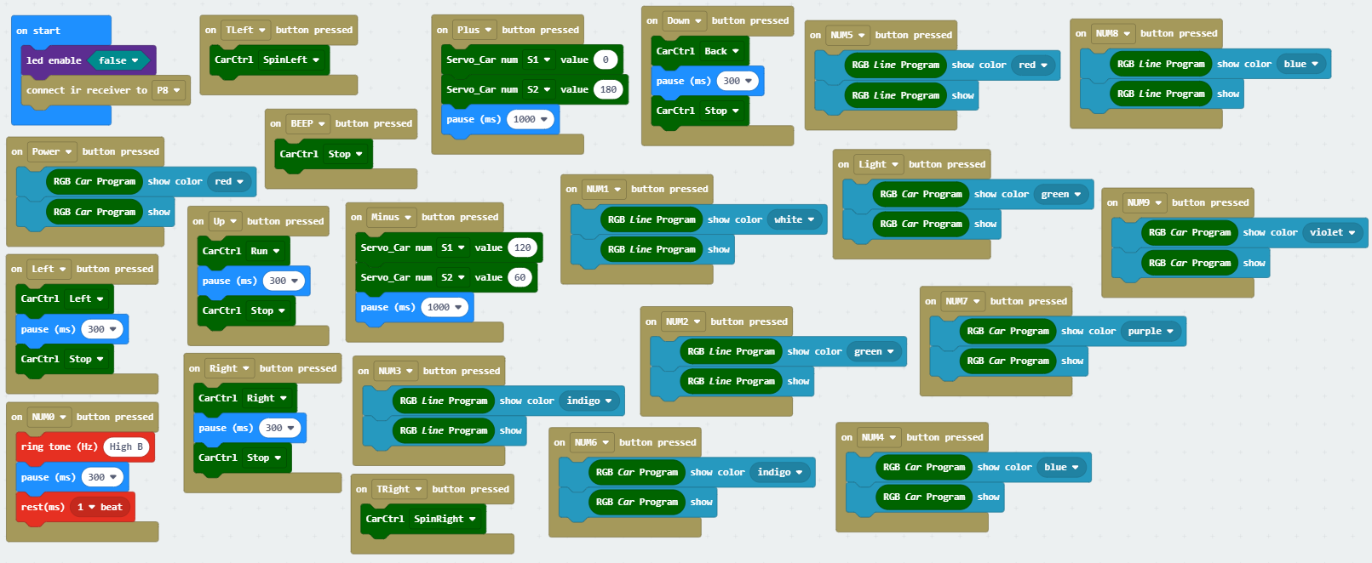

6-6 total program

The locations of blocks in the total program are shown in the following figure.

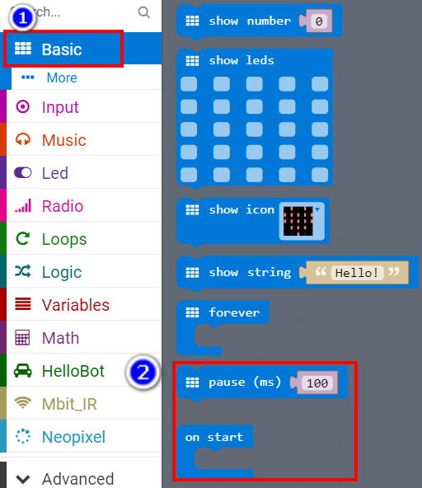

6-7

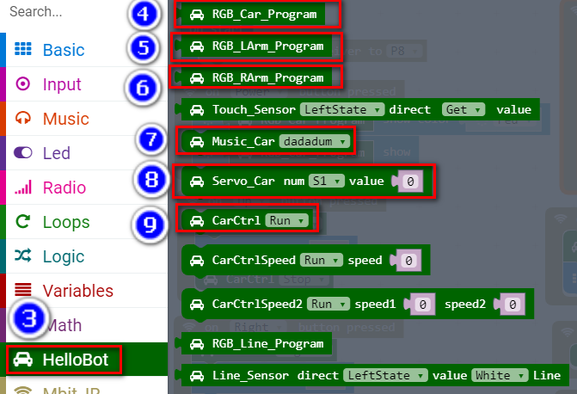

6-8

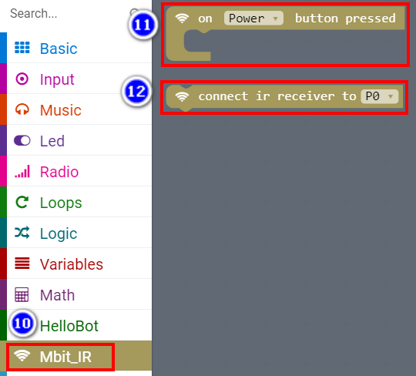

6-9

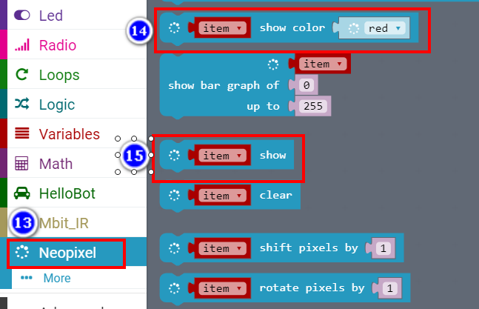

6-10

**4.Download programming**

You need to make sure that the micro:bit development board is connected to the computer. Then you should click on the download in the lower left corner as shown in 6-11 to download the program to micro:bit.

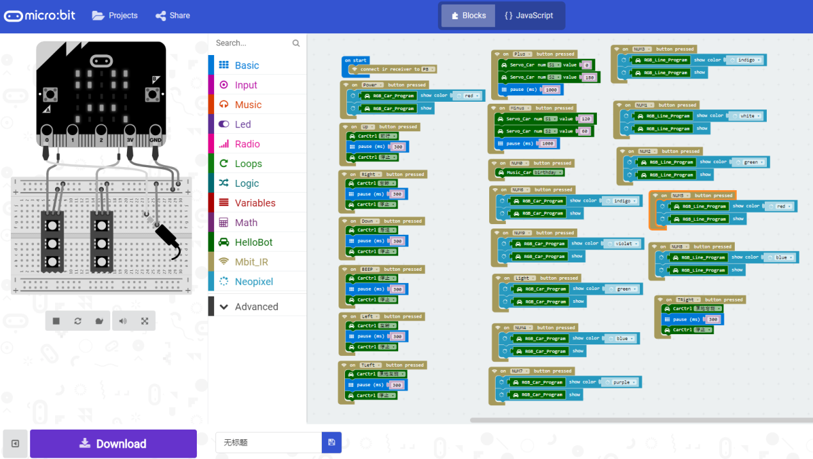

6-11

**5.Phenomenon**

After the code is uploaded. You can control HelloBot by infrared remote controller. When you presskey, clamp will close. When you presskey, clamp will open. As shown in the following figure. (Just for example)

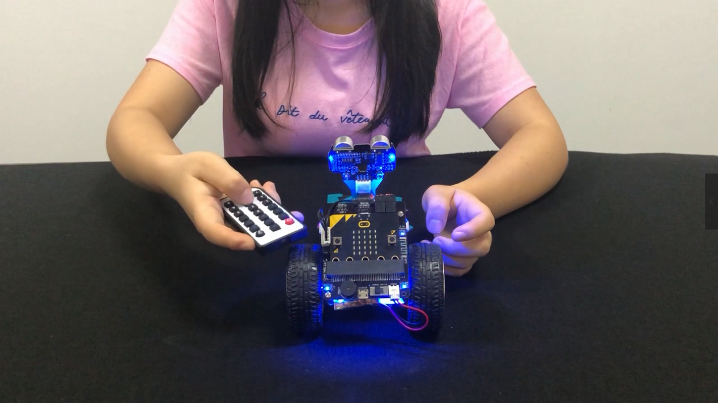

6-12

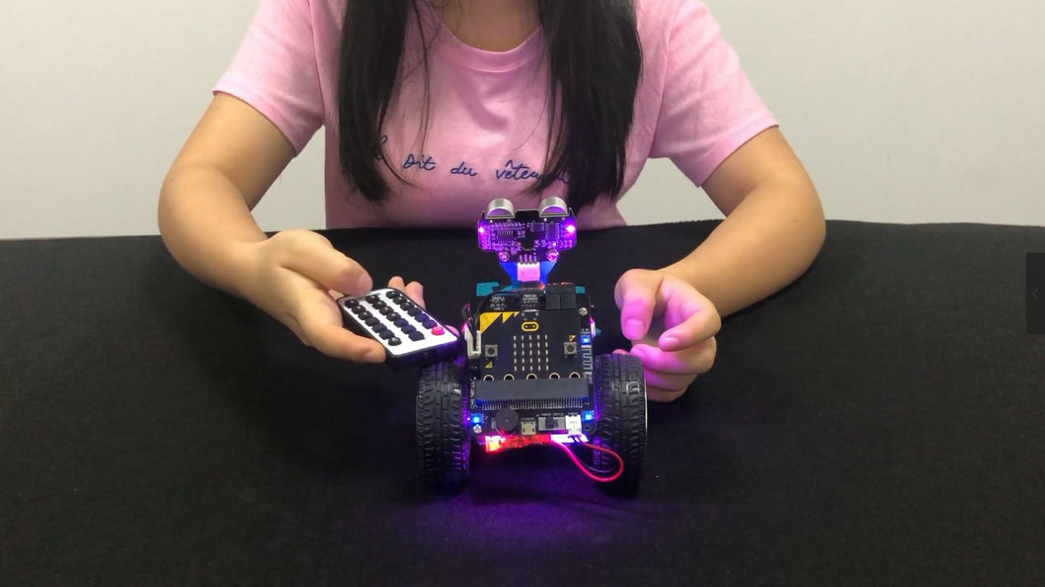

6-13